# Data Exploration:

# Top 5 Sector in Trading

The Financials sector is the largest sector in the Saudi exchange. Now let us explore the five top sectors:

1. **Financials sector**

**The percentage change for the Financials sector**

Here we see the scatter plot as a straight line over the years, and this is due to the limitation of profit and loss.

**Trading compnies in Financial Sector over the Years**

Here we observe the increase in companies whose shares are traded in the financial sector between 2002-2014 and the stability from 2014-2019. Then the big drop happened in 2020 due to Covid-19.

## **Exploring year 2020 in Financials sector**

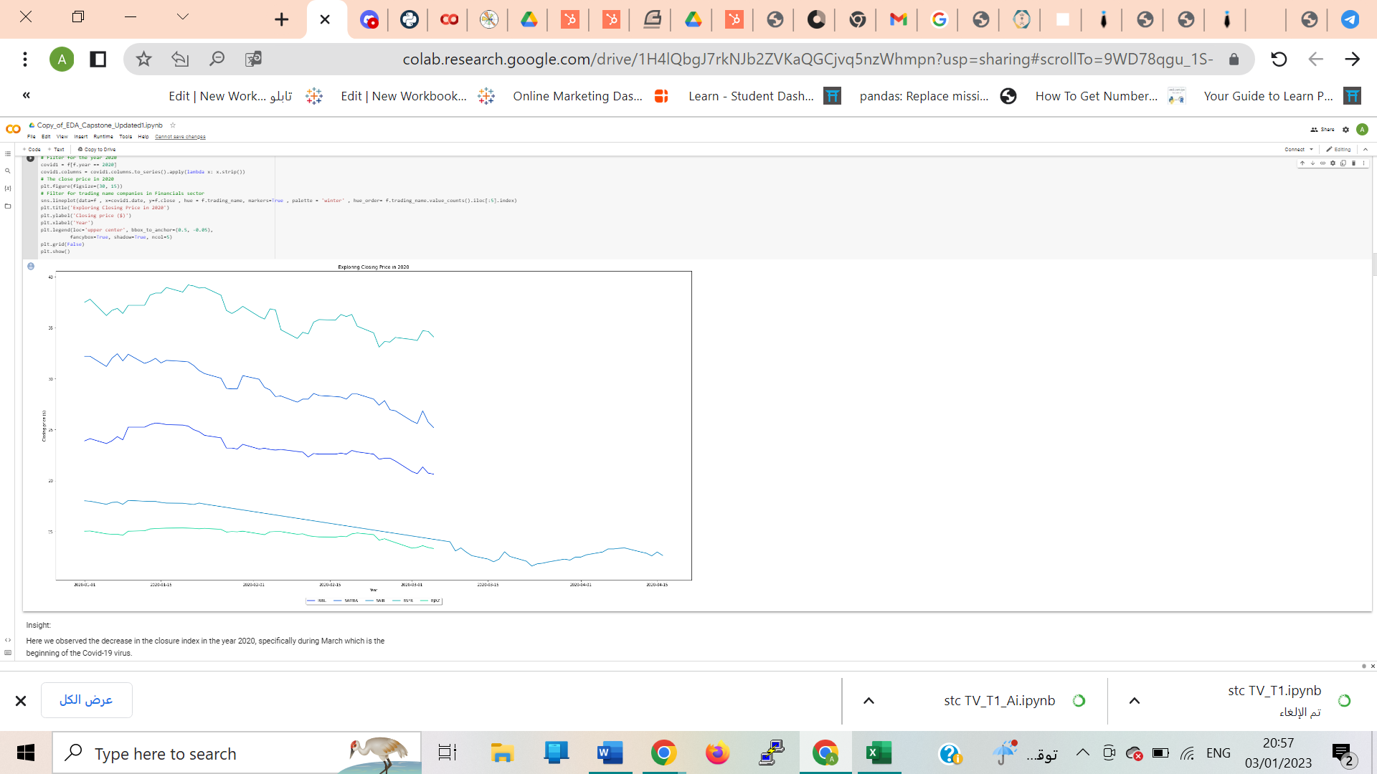

Insight: Here we observed the decrease in the closure index in the year 2020, specifically during March which is the beginning of the Covid-19 virus.

## **Closing price of Saudi Stocks in the Financial Sector**

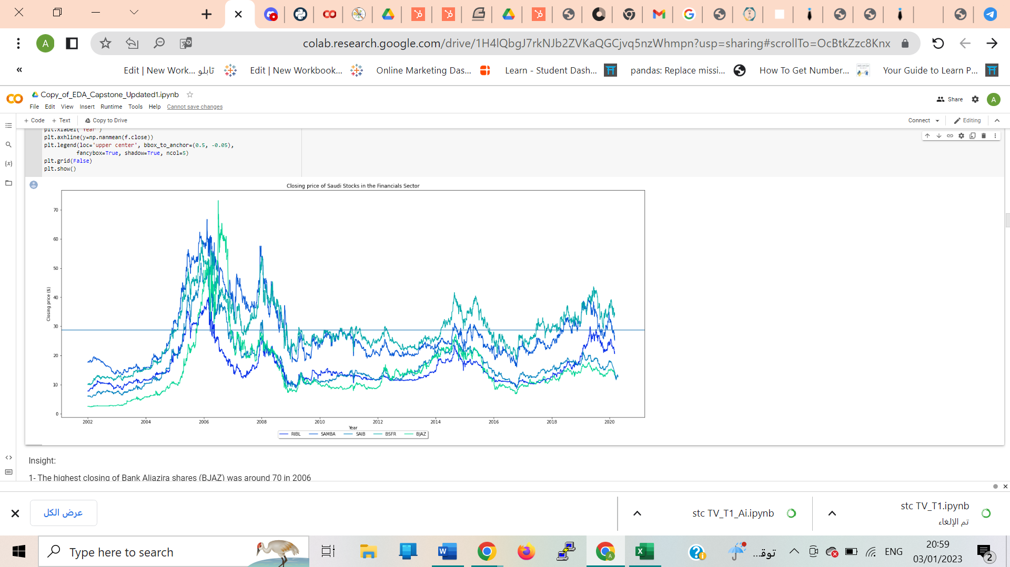

### 1- The highest closing of Bank Aljazeera shares (BJAZ) was around 70 in 2006

### 2- The highest closing of Banque Saudi Fransi (BSFR) shares was around 60 in 2006

### 3- The highest closing of Saudi Investment Bank (SAIB) shares was around 50 in 2006

### 4- The highest closing of Samba Financial Group (SAMIBA) shares was around 75 in 2006

### 5- The highest closing of Riyad Bank (RIBL) shares was around 40 in 2006.

### All the companies have close price above the average

# Filter Materials

## **The percentage change for the Materials sector**

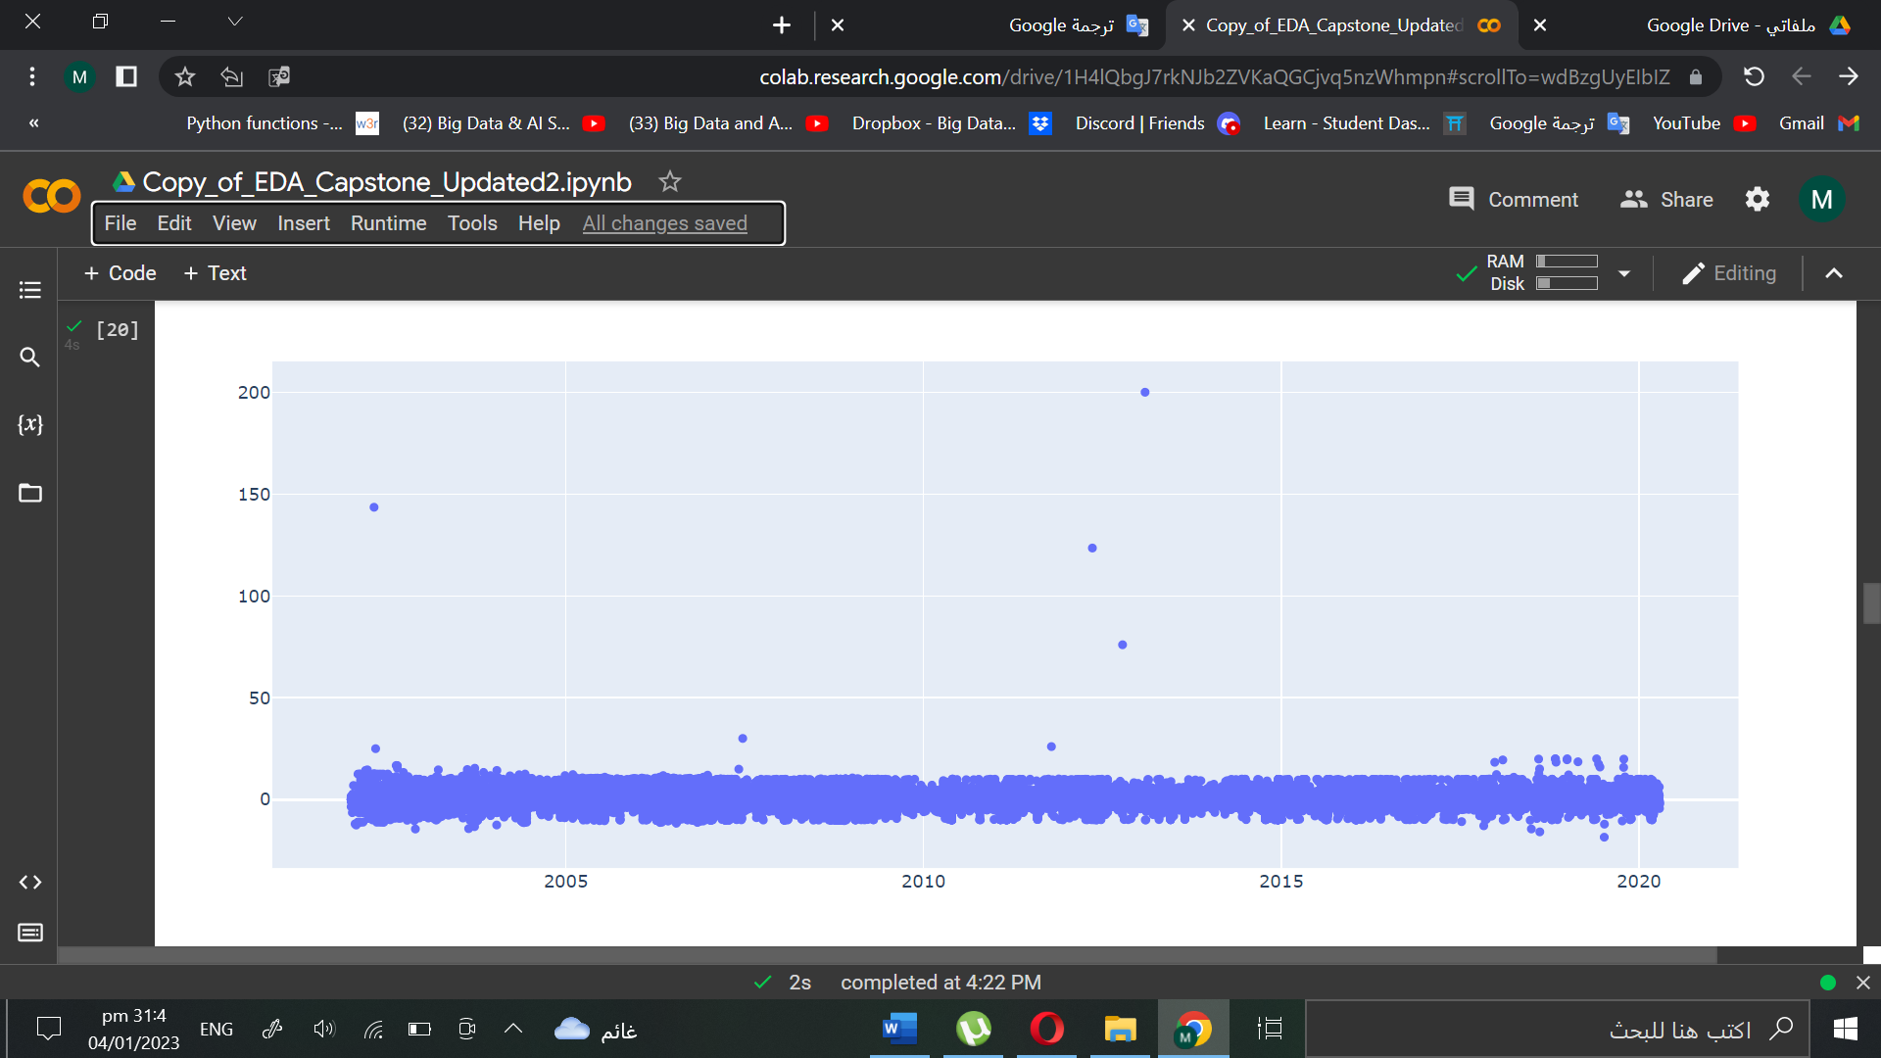

### Here we see the scatter plot as a straight line over the years, and this is due to the limitation of profit and loss.

## **Trading companies in Materials Sector over the Years**

### Here we observe the increase in companies whose shares are traded in the Materials sector between 2002-2014 and the stability from 2014-2019. Then the big drop happened in 2020 due to Covid-19.

**Exploring 2020 in Materials Sector**

### Here we observed the decrease in the closure index in the year 2020, specifically during March which is the beginning of the Covid-19 virus.

**Closing price of Saudi Stocks in the Materials Sector**

1- The highest closing of Bank Aljazira shares (YCC) was around 110 in 2005

2- The highest closing of Saudi Cement Co (SAUDI CEMENT) shares was around 125 in 2015

3- The highest closing of Saudi Arabian Fertilizer Co (SAFCO) shares was around 150 in 2009

4- The highest closing of National Industrialization Co (TASNEE) shares was around 75 in 2006

5- The highest closing of Saudi Basic Industries Corp (SABIC) shares was around 250 in 2006

1. **Filter Consumer Staples:**

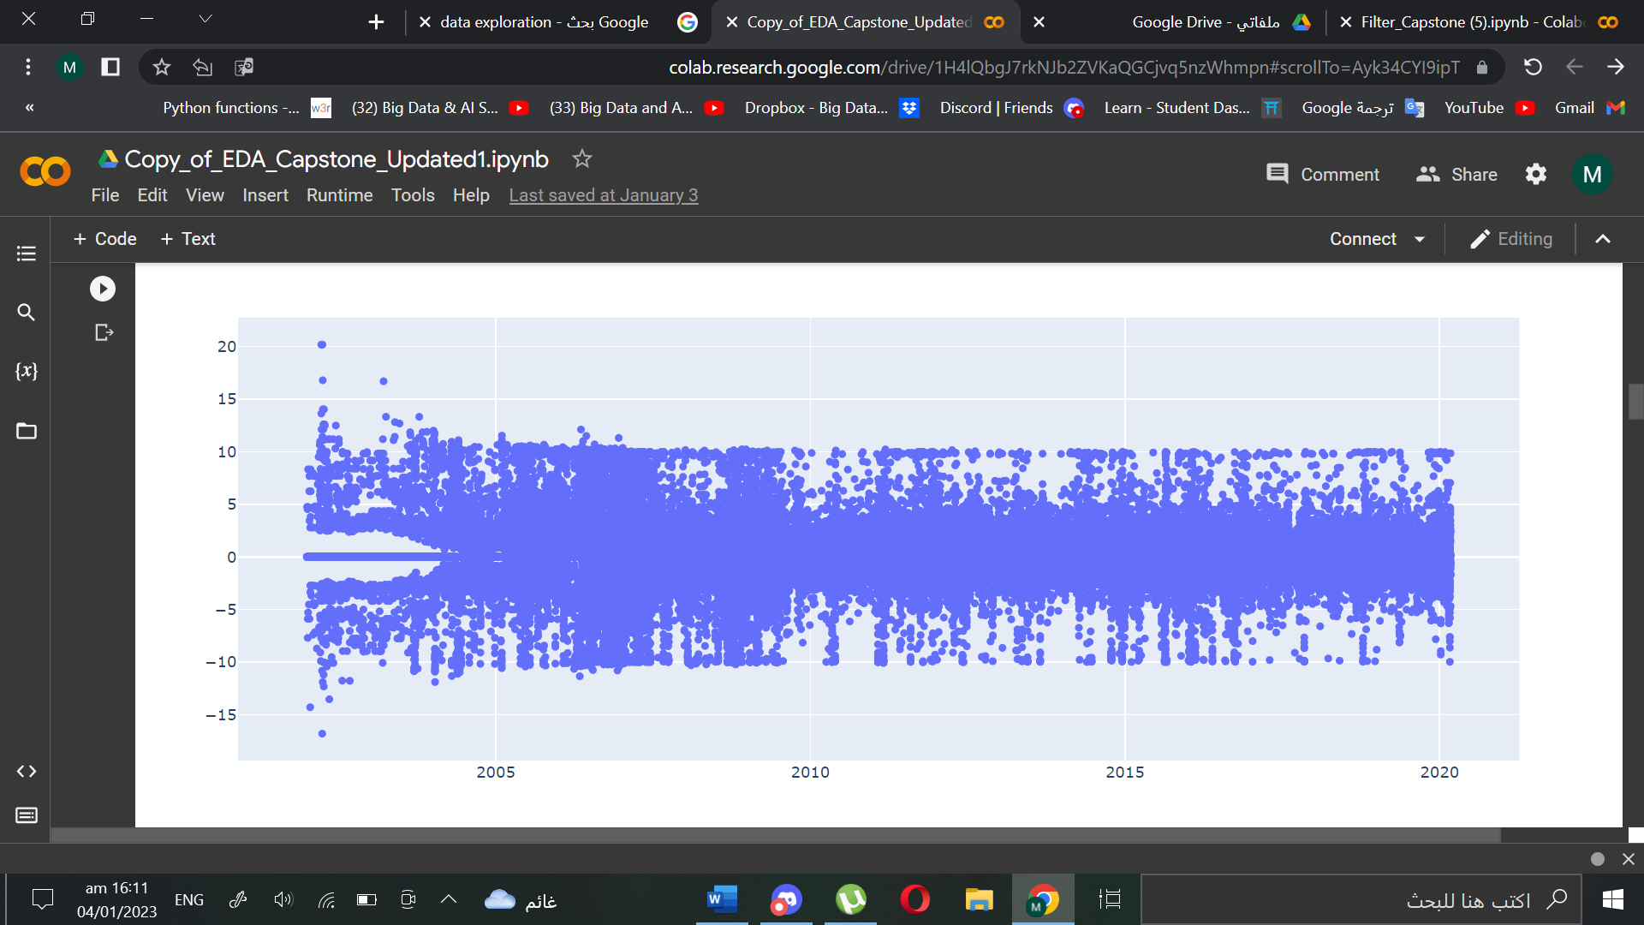**The percentage change for the Consumer Staples sector**

Here we see the scatter plot as a straight line over the years, and this is due to the limitation of profit and loss.

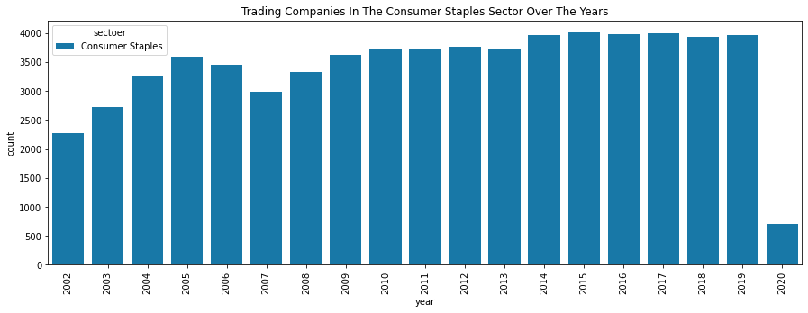**Trading companies in Consumer Staples Sector over Years**

Here we observe the increase in all years. Then the big drop happened in 2020 due to Covid-19.

**Exploring 2020 in Consumer Staples Sector**

Here we observed the decrease in the closure in the year 2020, specifically during March which is the beginning of the Covid-19.

**Closing price of the Consumer Staples Sector**

1- The highest closing of Mobile Telecommunication Company Saudi Arabia(Zain KSA) shares was around 110 in 2008

2- The highest closing of Saudi Research and Marketing Group (SRMG) shares was around 100 in 2018

3- The highest closing of Etihad Etisalat Co (ETIHAD ETISALAT) shares was around 100 in 2006

4- The highest closing of Saudi Telecom Co (STC) shares was around 180 in 2006

5- The highest closing of Tihama Advertising and Public Relations Co (TAPRCO) shares was around 800 in 2014

1. **Filter Industrials:**

**The percentage change for the Industrials sector**

Here we see the scatter plot as a straight line over the years, and this is due to the limitation of profit and loss.

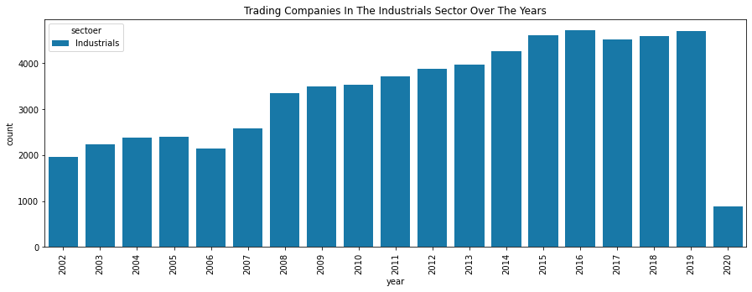**Number of Industrials Companies Sector over the Years**

Here we observe the increase in companies whose shares are traded in the Industrials sector between 2002-2016 and the stability from 2017-2019. Then the big drop happened in 2020 due to Covid-19.

**Exploring 2020 in Industrials Sector**

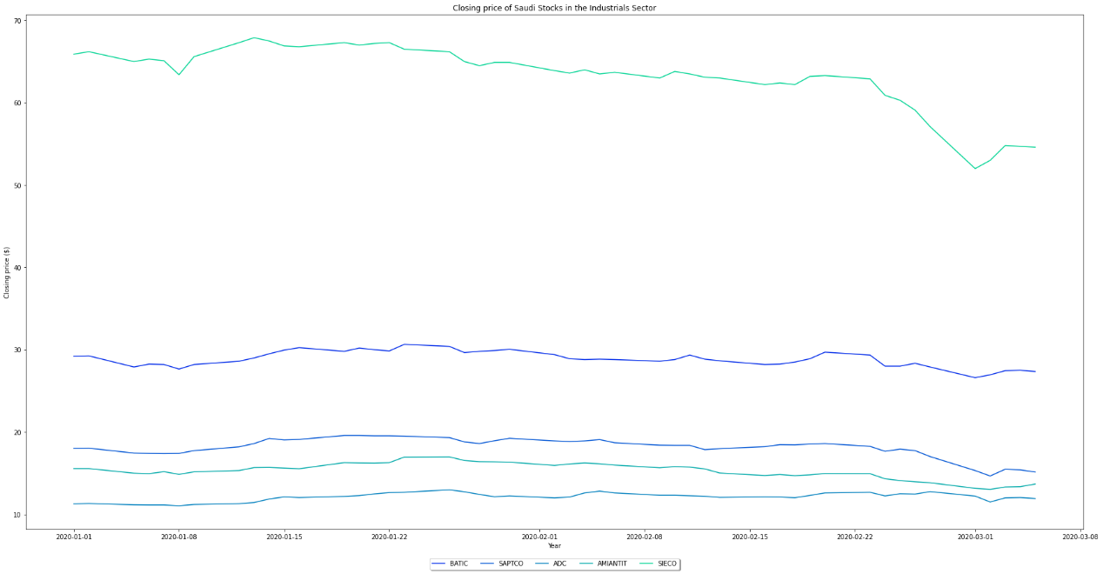

Here we observed the decrease in the closure in the year 2020, specifically during March which is the beginning of the Covid-19 virus.

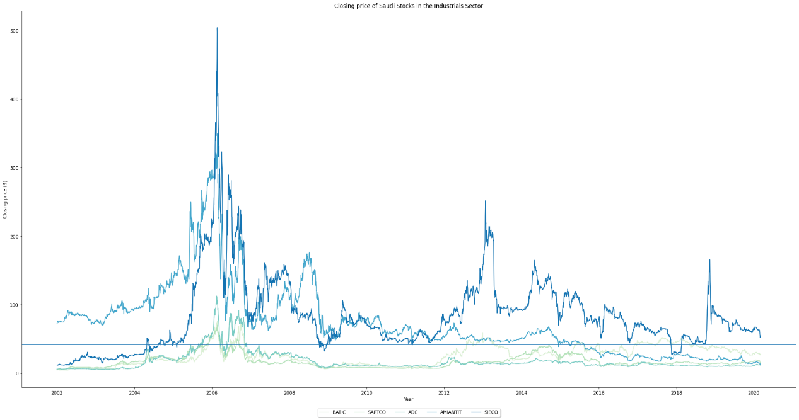**Closing price of Saudi Stocks in the Industrials Sector**

1- The highest closing of Saudi Industrial Export Co (SIECO) shares was around 500 in 2006

2- The highest closing of Saudi Arabian Amiantit Co (AMIANTIT) shares was around 350 in 2006

3- The highest closing of Al-Ahsa Development Co (ADC) shares was around 100 in 2006

4- The highest closing of Saudi Public Transport Co (SAPTCO) shares was around 80 in 2006

5- The highest closing of Batic Investments and Logistics Co (BATIC) shares was around 80 in 2006

1. **Filter Consumer Discretionary:**

**The percentage change for the Consumer Discretionary sector**

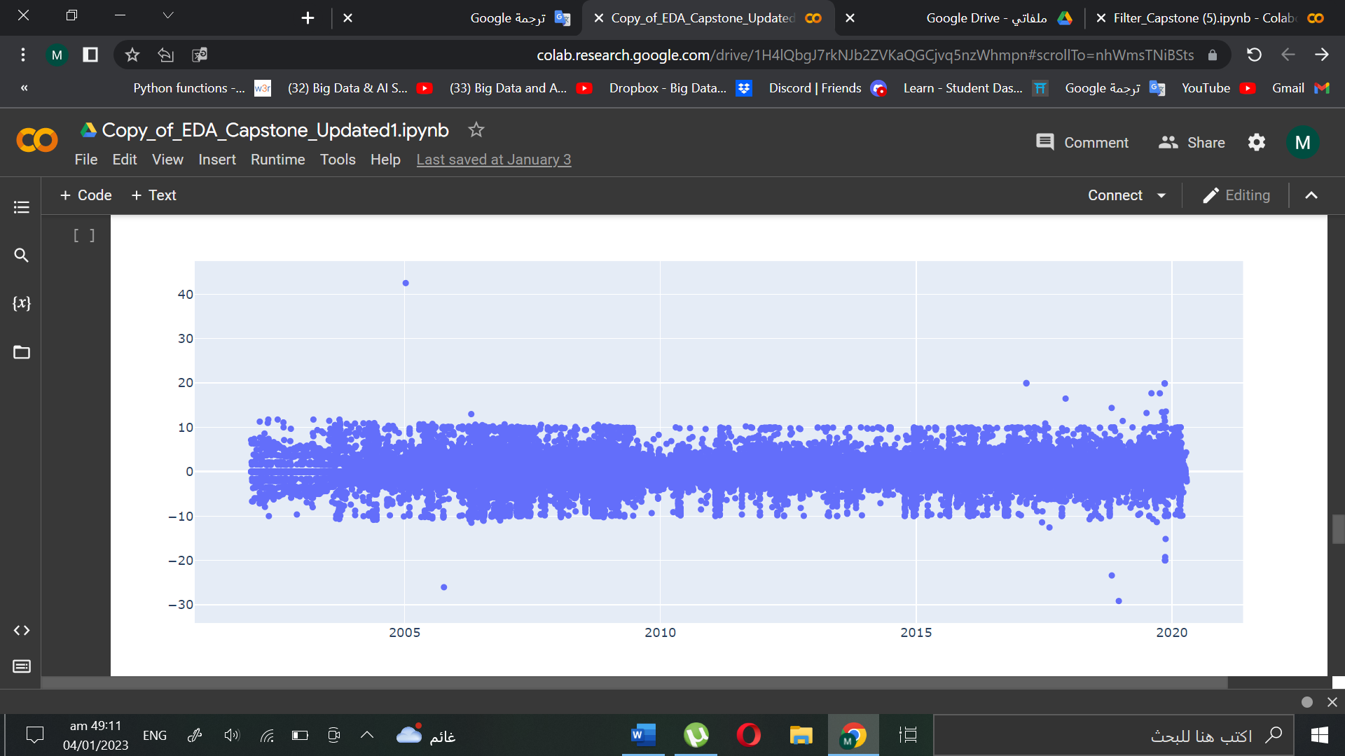

Here we see the scatter plot as a straight line over the years, and this is due to the limitation of profit and loss.

**Trading companies in Consumer Discretionary sector over the Years**

Here we observe the increase in companies whose shares are traded in the Consumer Discretionary sector between 2002-2019. Then the big drop happened in 2020 due to Covid-19.

**Exploring year 2020 in Consumer Discretionary Sector**

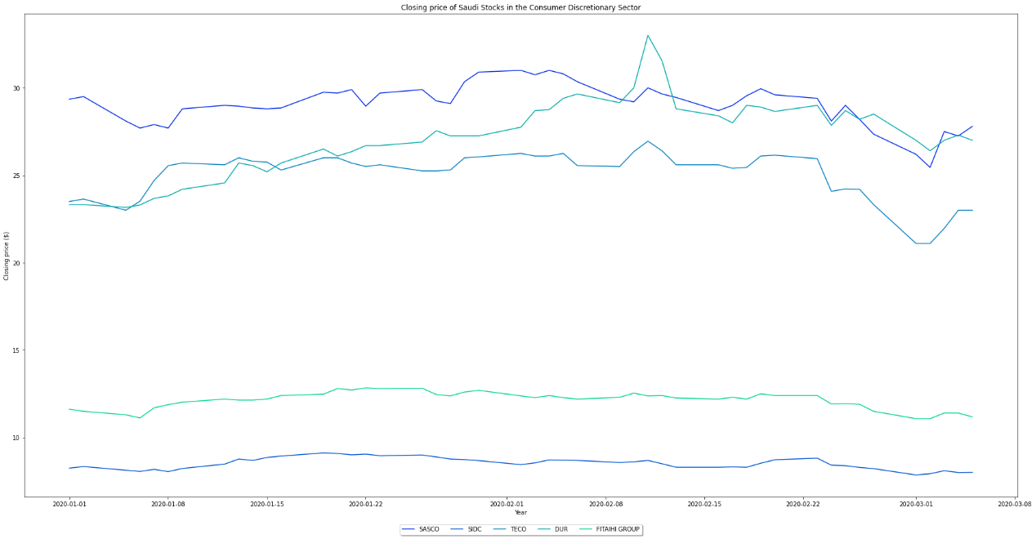 Here we observed the Consumer Discretionary Sector was not affected in the year of Covid-19.

**Closing price of Saudi Stocks in the Industrials Sector**

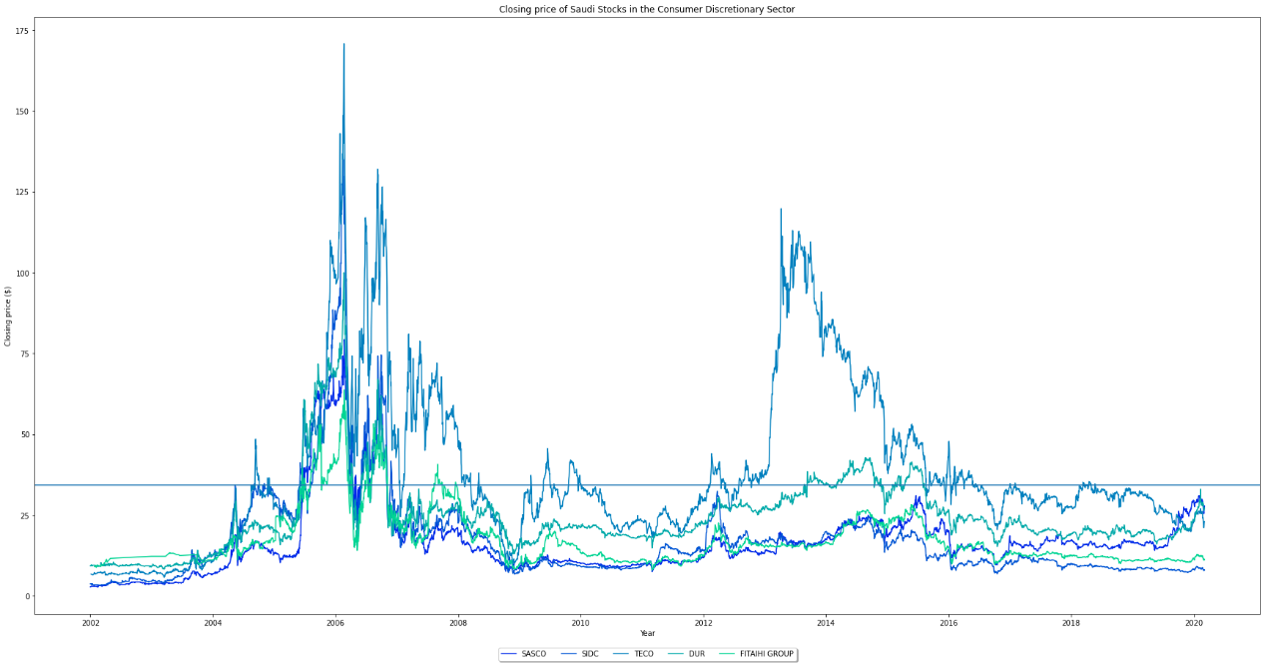

1- The highest closing of Fitaihi Holding Group (FITAIHI GROUP) shares was around 60 in 2006

2- The highest closing of Dur Hospitality Co (DUR) shares was around 100 in 2006

3- The highest closing of Tourism Enterprise Co (TECO) shares was around 175 in 2006

4- The highest closing of Saudi Industrial Development Co (SIDC) shares was around 130 in 2006

5- The highest closing of Saudi Automotive Services Co (SASCO) shares was around 80 in 2006.

**The Pair plot:**

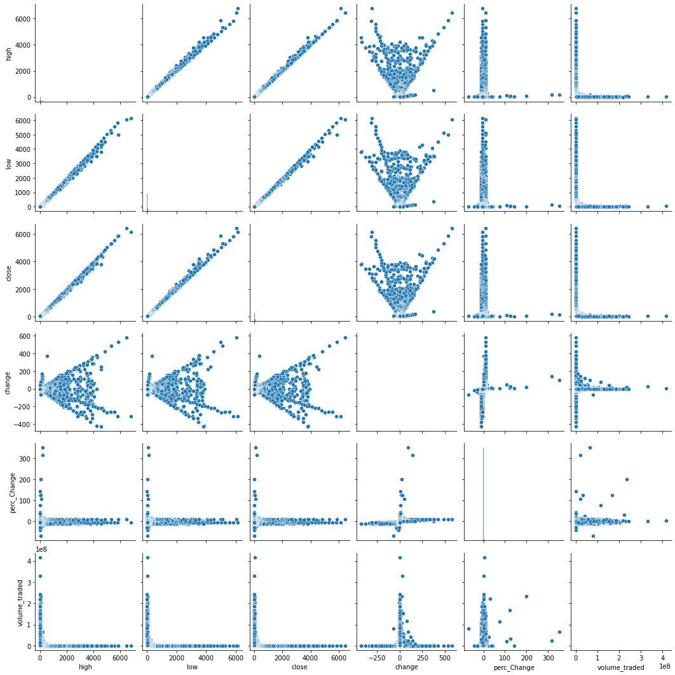

There are linear relationships. Which indicate that there is dependent attribute.